**TAPPETINO MAGNETICO PER MIGLIORARE L’ADERENZA DELLE STAMPE.**

<https://www.amazon.it/SOOWAY-Costruisci-superficie-riscaldato-compatibile/dp/B07JMT8C9R/ref=pd_rhf_ee_s_rp_c_2_5/262-9294036-0169061?pd_rd_w=zUkwt&pf_rd_p=c68dd65f-c408-41fc-a2de-081daa3be0c4&pf_rd_r=8G1TV41T5C5PE4XHY36W&pd_rd_r=535baa9b-220a-44b8-9315-b20265e6a2ec&pd_rd_wg=TV20e&pd_rd_i=B07JMT8C9R&psc=1>

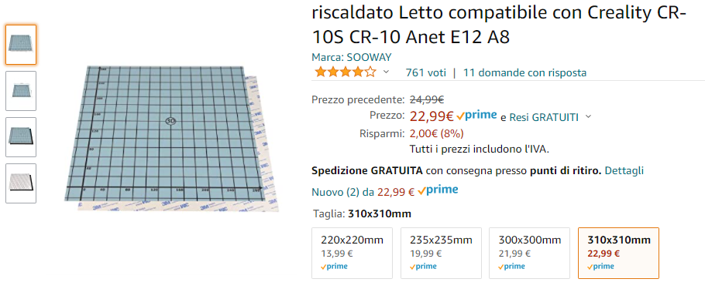

**ESTRUSORE REDREX**

[**https://www.amazon.it/Redrex-Extruder-Performance-Upgrading-Geeetech/dp/B07Q5RNRR6?pd_rd_w=8CHaf&pf_rd_p=d074fa1c-7847-4596-a7f8-9d85e5984d4e&pf_rd_r=9ZF4SVK9VZHT9VWFQD0R&pd_rd_r=07e44cc1-554d-46ee-ac65-437824058c0a&pd_rd_wg=KeUyp&pd_rd_i=B07Q5RNRR6&psc=1&ref_=pd_bap_d_rp_2_i**](https://www.amazon.it/Redrex-Extruder-Performance-Upgrading-Geeetech/dp/B07Q5RNRR6?pd_rd_w=8CHaf&pf_rd_p=d074fa1c-7847-4596-a7f8-9d85e5984d4e&pf_rd_r=9ZF4SVK9VZHT9VWFQD0R&pd_rd_r=07e44cc1-554d-46ee-ac65-437824058c0a&pd_rd_wg=KeUyp&pd_rd_i=B07Q5RNRR6&psc=1&ref_=pd_bap_d_rp_2_i)

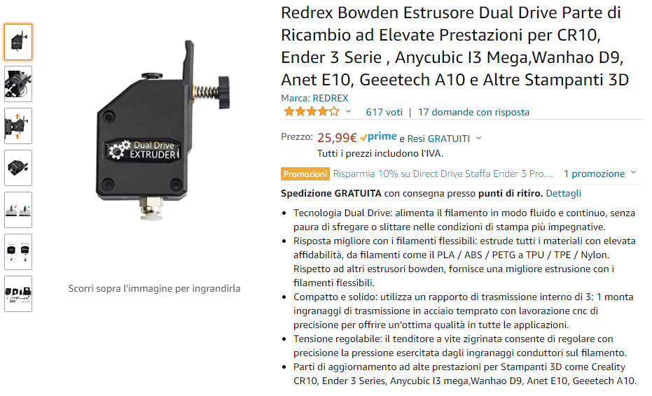

**TUBO IN PTFE CAPRICORN**

[**https://www.amazon.it/Capricorn-connessione-pneumatica-connettore-stampante/dp/B0861MG442?pd_rd_w=8CHaf&pf_rd_p=d074fa1c-7847-4596-a7f8-9d85e5984d4e&pf_rd_r=9ZF4SVK9VZHT9VWFQD0R&pd_rd_r=07e44cc1-554d-46ee-ac65-437824058c0a&pd_rd_wg=KeUyp&pd_rd_i=B0861MG442&psc=1&ref_=pd_bap_d_rp_6_i**](https://www.amazon.it/Capricorn-connessione-pneumatica-connettore-stampante/dp/B0861MG442?pd_rd_w=8CHaf&pf_rd_p=d074fa1c-7847-4596-a7f8-9d85e5984d4e&pf_rd_r=9ZF4SVK9VZHT9VWFQD0R&pd_rd_r=07e44cc1-554d-46ee-ac65-437824058c0a&pd_rd_wg=KeUyp&pd_rd_i=B0861MG442&psc=1&ref_=pd_bap_d_rp_6_i)

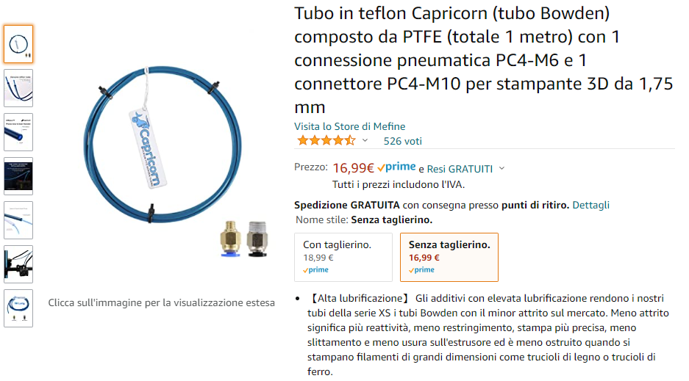

**DRIVER TMC2209**

[**https://it.aliexpress.com/item/4000552353605.html?spm=a2g0o.productlist.0.0.22727e04dFaxV7&algo_pvid=520fa5eb-7239-4be4-a2b2-f8c945248a92&aem_p4p_detail=202110301011001012255119903950017172113&algo_exp_id=520fa5eb-7239-4be4-a2b2-f8c945248a92-5&pdp_ext_f=%7B%22sku_id%22%3A%2210000002873880037%22%7D**](https://it.aliexpress.com/item/4000552353605.html?spm=a2g0o.productlist.0.0.22727e04dFaxV7&algo_pvid=520fa5eb-7239-4be4-a2b2-f8c945248a92&aem_p4p_detail=202110301011001012255119903950017172113&algo_exp_id=520fa5eb-7239-4be4-a2b2-f8c945248a92-5&pdp_ext_f=%7B%22sku_id%22%3A%2210000002873880037%22%7D)

